**The Report on the EQ’s Problem**

**About the question of EQ:** Pegatron is trying to modify frequency point of EQ that based on RK_EQ.pdf document, process does not change and keep 5 points. Frequency points are changed to 60,400, 1k, 2.5k, 6.3k. EQ coefficient table generated by the flow descripts in RK’s document.

　　To play specific frequency sin-wave file (like 60, 400, 1k) and adjust the gain in customer EQ setting page during music file is under playing. There has problem if the specific gain is set below 0db, it will cause no sound output or sound wave distortion, but if EQ mode changes back to normal, sound outputs normally again. Pegatron also test on NanoD-G EVB with this table, result is the same. In this case, only change the coefficient table but the result is not in expected.

**The reason for the above phenomenon:** because of the 60Hz belongs to low frequency, we should left shift 20 bits when fixed EQ coefficients (Page10 in RK_EQ.pdf). We present the EQ gain curves in two different shift situations (eg: dB =-2, f0 =60Hz, fs=44100Hz).

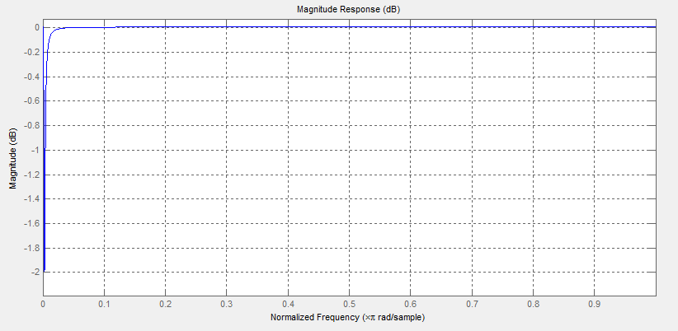

Fig1. EQ gain curve generated by MATLAB

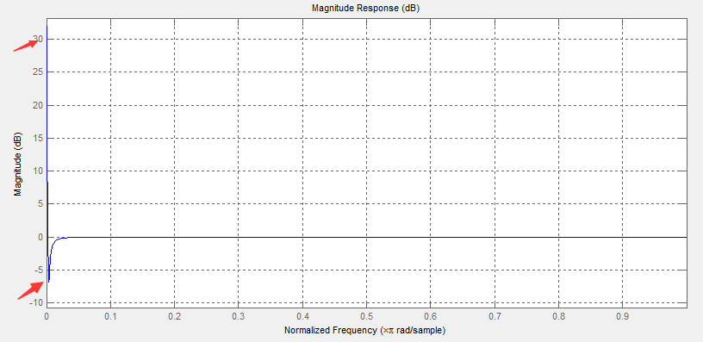

Fig2. EQ gain curve when left shift 13 bits

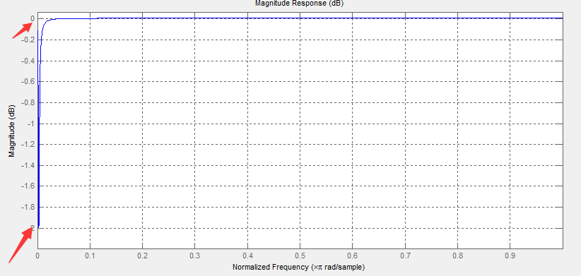

Fig3. EQ gain curve when left shift 20 bits

Fig1 shows EQ gain curve based on part 3 of RK_EQ.pdf, the Fig2 and Fig3 present EQ gain curve in different fixed ways. We can find that the maximum EQ gain in Fig2 more than 30dB and the minimum gain is approximately -7dB cannot meet our requirement of EQ gain. Therefore, if we set the EQ coefficient in Fig2 to eq_table (rk_eq.c), some of the output dates maybe overflow which will cause no sound output or sound wave distortion.